|  |  |  |  |
| --- | --- | --- | --- |
| **Inglés** | **Español** | **Inglés** | **Español** |
| **To talk about where someone lives** |  | 23. to give |  |
| 1. Close (to), near |  | 25. to feed the dog |  |
| 1. Far (from) |  | 26. to make the bed |  |
| 1. To live |  | 27. to wash (the car, the dishes, the clothes) |  |
| 1. Apartment |  | 28. to clean the bathroom |  |
| 1. Bathroom |  | 29. to vacuum |  |
| 1. kitchen |  | 30. to put, place |  |
| 1. dining room |  | 31. to set the table |  |
| 1. room |  | 32. chores |  |
| 1. Coat |  | 33. to dust |  |
| 1. Home office |  | 34. to take out the trash |  |
| 1. Stairs; stairway |  | **To describe household items:** |  |
| 1. garage |  | 35. limpio (a)(s) |  |
| 1. story, floor |  | 36. sucio(a)(s) |  |
| 1. Ground floor |  | **Other useful words:** |  |
| 1. Second floor |  | 37. enough; rather |  |
| 1. Living room |  | 38. ¿Cuáles? |  |
| 1. Third floor |  | 39. el dinero |  |
| 1. basement |  | 40. un momento |  |
| **To name household chores** |  | 41. ¿Qué estás haciendo? |  |
| 1. to straighten up the room |  | 42. recibir |  |
| 1. to help |  | 43. si |  |
| 1. to cook |  | **EXTRA VOCAB: pg. 473** |  |
| 1. to cut the lawn |  | 44. balcony | El balcón, los balcones |
| 45. stove | La estufa | 61. to rake leaves | Rastrillar las hojas |
| 47. garden | El jardín, los jardines | 62. to mop | trapear |
| 48. laundry room | El lavadero | **Los colores** |  |
| 49. washing machine | La lavadora | 63. light blue | Azul claro |
| 50. dishwasher | El lavaplatos, los lavaplatos | 64. navy blue | Azul marino |
| 51. microwave oven | El microondas, los microondas | 65. dark blue | Azul oscuro |
| 52. furniture | Los muebles |  |  |
| 53. patio | El patio |  |  |
| 54. refrigerator | El refrigerador |  |  |
| 55. clothes dryer | La secadora |  |  |
| 56. armchair | El sillón, los sillones |  |  |
| 57. sofa | El sofa |  |  |
| 58. dressing table | El tocador |  |  |
| **Los quehaceres:** | **Chores:** |  |  |
| 59. to shovel snow | Quitar la nieve con la pala |  |  |
| 60. to clear the table | Quitar los platos de la mesa |  |  |

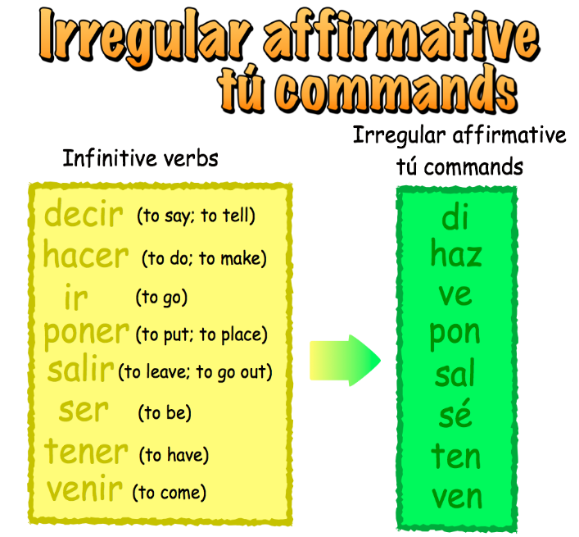**INFORMAL COMMANDS/MANDATES (MANDATOS)~**

1. Take the _____________________________________
2. Drop the ______________________________________
3. You are left with _______________________________

**Examples:**

Correr=

Bailar=

Escribir=

Lavar=

Limpiar=

